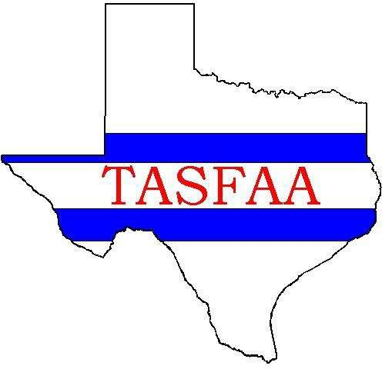
Board of Directors
2022-2023
President
Dede Gonzales
Texas State University
Vice President
JoEllen Price
Houston Community College
President-Elect
Denise Welch
Panola College
Past-President
Robert Merino

Treasurer
Monica Smart
Hardin-Simmons University
Secretary
Alexandra Hellinger
Alamo Colleges District

Members-At-Large
JoEllen Price
Houston Community College
Chandra Gonzales
South Texas College of Law
Joseph Ruiz
Del Mar College
Keith Hoelscher
Angelo State University
Thomas Ratliff
Abilene Christian University
Maria Serna
Texas A&M – Corpus Christi
Christy Miller
Wayland Baptist University
Leandra Garcia
St. Mary’s University

Texas Association of Student Financial Aid Administrators

January 29, 2023

Dr. Harrison Keller
Commissioner of Higher Education
Texas Higher Education Coordinating Board
PO Box 12788
Austin, TX 78711

RE: Reducing Inefficiencies to Better Allocate Financial Aid for Student Success

Dear Commissioner Keller:
On behalf of the Texas Association of Student Financial Aid Administrators (TASFAA), we thank you for your continued support of Texas students and their pursuit of higher education. TASFAA is an organization of over 130 Texas colleges and universities with more than 2,200 professionals committed to advancing access to postsecondary education as well as advocating for informed public policies regarding student financial aid programs.
We write to share with you our below legislative goals to eliminate inefficiencies in state financial aid programs that, if not addressed, will continue to impose barriers to students accessing a higher education. Our interest is to determine whether our four goals are in alignment with those of the Texas Higher Education Coordinating Board (THECB). We would welcome, at your earliest convenience, an opportunity to meet with you to discuss these goals and those of the THECB.

Goals:

- Align State Satisfactory Academic Progress (SAP) requirements for financial aid eligibility with Federal standards.
- Align the State’s Selective Service registration requirements for financial aid eligibility with new Federal standards.
- Align State requirements regarding financial aid eligibility and convictions with new Federal standards.
- Align the State’s Texas Educational Opportunity Grant (TEOG) program with the TEXAS Grant to permit the use of Federal Pell Grant funds to cover the required TEOG match. Thus, allowing institutional funds to assist a greater number of financially-deserving students.

Goal I

Align the State’s Satisfactory Academic Progress (SAP) policies with the Federal policies. Both Federal and State student financial aid programs require recipients to be making SAP toward earning their postsecondary credentials or degrees. However, the misalignment between Federal and State SAP standards creates confusion and a potential barrier to a students’ ability to progress toward their credential/degree—e.g., different minimum Grade Point Averages: Federal = 2.0 GPA; and State = defers to institutional minimum after year one and a 2.5 GPA after year two.

Recommendation: It is imperative that State SAP policies align with those of the Federal government, thus, enabling all students to have one SAP policy to follow to graduation.

Goal II

In the Federal Consolidated Appropriations Act of 2021, Congress eliminated the requirement that students be registered with Selective Service in order to receive Title IV financial aid. This change creates a significant difference between Federal law and State law as State law still requires students to file for Selective Service in order to receive State financial aid. As a result, students face an increased challenge in navigating the different Selective Service standards when applying for and receiving State and Federal financial assistance.

Recommendation: Conform the State Selective Service requirement with the Federal requirement so all students can be eligible for State supported financial aid.

Goal III

The Federal government has eliminated convictions as a barrier to students receiving financial aid. However, this change has not occurred with respect to State student financial aid programs. This nonalignment increases the potential for confusion during the financial aid application process for students and further limits their access to postsecondary education as well as their ultimate ability to better contribute to the Texas workforce.

Recommendation: Conform the State requirement with the Federal requirement so all students can be eligible for State supported financial aid.

Goal IV

Currently, the Texas Educational Opportunity Grant (TEOG) and TEXAS Grant programs require institutions to make up any difference between a student’s grant amount and the cost of their tuition and fees. However, the TEXAS Grant, which is limited to four-year institutions, is allowed to use Federal Pell Grant funds to help cover this difference. Community colleges, which participate in the TEOG program, are not allowed to use Pell Grant funds in this manner and must instead use institutional monies. This difference places the State’s community colleges at a significant disadvantage.

Recommendation: Amend the relevant statute to allow community colleges to use Federal Pell Grant funds to help cover the difference between their students’ TEOG award amount and their cost of tuition and fees. Thus, better aligning this state program with the TEXAS Grant program.

We very much appreciate your time in reading our Association’s legislative goals. We look forward to meeting with you to address these important matters. Please feel free to contact me at any time.

Sincerely,
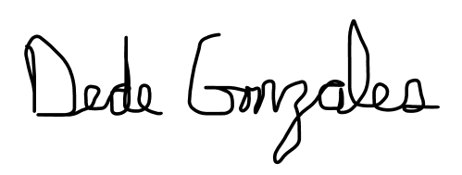
Dede L. Gonzales
President
president@tasfaa.org

